zKeluhan

Nama Project : SuaraMoklet //
Tagline : Your Voice, Better School

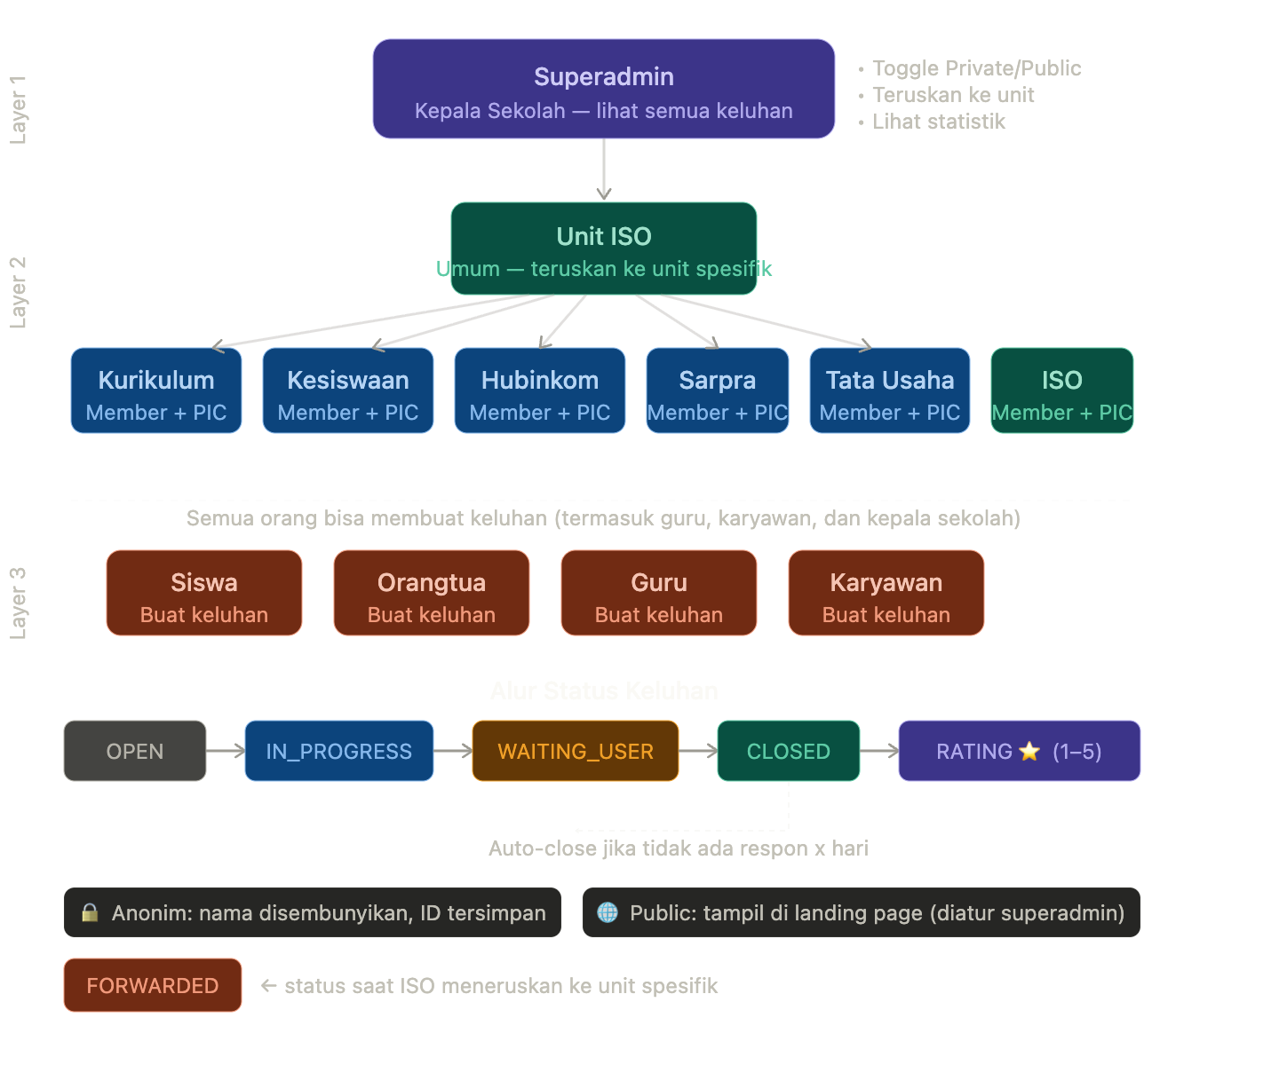
# SuaraKita — Project Task List
> Periode: 1 Juli – 31 Agustus 2025 |
Tim: 1 Backend (NestJS) + 1 Frontend (Next.js)
---

## 📋 Ringkasan Sprint

| Sprint | Periode | Fokus |
|--------|---------|-------|
| Sprint 1 | 1–7 Juli | Setup, Auth, Database |
| Sprint 2 | 8–14 Juli | Core Backend API |
| Sprint 3 | 15–21 Juli | Unit & Role Management |
| Sprint 4 | 22–28 Juli | Frontend Foundation + Landing Page |
| Sprint 5 | 29 Juli–4 Agustus | Core Frontend Features |
| Sprint 6 | 5–11 Agustus | Dashboard Unit & Admin |
| Sprint 7 | 12–18 Agustus | Notifikasi, Auto-close, Rating |
| Sprint 8 | 19–25 Agustus | Testing, Bug Fix, Deployment |
| Sprint 9 | 26–31 Agustus | Final QA, Dokumentasi, Serah Terima |
---

## 🗓️ Sprint 1 — Setup & Fondasi (1–7 Juli)

### Backend
- [ ] **BE-01** Init project NestJS + konfigurasi folder structure (modules, services, controllers)
- [ ] **BE-02** Setup Prisma + koneksi PostgreSQL + jalankan `prisma migrate dev`
- [ ] **BE-03** Seed data awal: 6 unit sekolah, 1 akun superadmin
- [ ] **BE-04** Setup environment variables (.env) dan konfigurasi config module
- [ ] **BE-05** Implementasi Auth: register & login dengan JWT (access token + refresh token)
- [ ] **BE-06** Guard & decorator: `@Roles()`, `@CurrentUser()`, `JwtAuthGuard`
- [ ] **BE-07** Setup Swagger/OpenAPI dokumentasi otomatis

### Frontend
- [ ] **FE-01** Init project Next.js (App Router) + TypeScript + Tailwind CSS
- [x] **FE-02** Setup folder structure (app, components, lib, hooks, types)
- [ ] **FE-03** Konfigurasi Axios/fetch wrapper + setup environment variables
- [ ] **FE-04** Setup Auth context + Zustand/Jotai untuk state management
- [ ] **FE-05** Halaman Login & Register (UI + integrasi API)
- [ ] **FE-06** Protected Route wrapper + middleware Next.js

---

## 🗓️ Sprint 2 — Core Backend API (8–14 Juli)

### Backend
- [ ] **BE-08** CRUD Users: get profile, update profile, deactivate user
- [ ] **BE-09** Upload media (gambar): integrasi Cloudinary/Supabase Storage + validasi tipe & ukuran file
- [ ] **BE-10** Complaint module: `POST /complaints` (buat keluhan baru + upload gambar)
- [ ] **BE-11** Complaint: `GET /complaints` dengan filter (status, unitId, visibility) + pagination
- [ ] **BE-12** Complaint: `GET /complaints/:id` detail keluhan
- [ ] **BE-13** Complaint: logika anonim — nama tidak dikembalikan ke response jika `isAnonymous: true`
- [ ] **BE-14** Comment module: `POST /complaints/:id/comments` (user & PIC bisa komentar)
- [ ] **BE-15** Comment: `GET /complaints/:id/comments` (threaded/nested)
- [ ] **BE-16** Unit test: Auth service + Complaint service (Jest)

---

## 🗓️ Sprint 3 — Unit, Role & Forwarding (15–21 Juli)

### Backend
- [ ] **BE-17** Unit module: CRUD unit + manage anggota unit (superadmin)
- [ ] **BE-18** UnitMembership: assign/remove user ke unit, set/unset PIC
- [ ] **BE-19** Guard: `UnitMemberGuard` — hanya anggota unit bisa lihat keluhan unitnya
- [ ] **BE-20** Guard: `UnitPICGuard` — hanya PIC yang bisa POST comment sebagai unit
- [ ] **BE-21** Forwarding API: `PATCH /complaints/:id/forward` — ISO meneruskan ke unit spesifik
- [ ] **BE-22** Superadmin: `PATCH /complaints/:id/visibility` — ubah private/public
- [ ] **BE-23** Superadmin: `GET /complaints` — lihat semua keluhan tanpa filter unit
- [ ] **BE-24** Status otomatis: setelah PIC komentar → status `IN_PROGRESS` atau `WAITING_USER`
- [ ] **BE-25** Auto-close: cron job harian cek keluhan > x hari tanpa aktivitas → tutup otomatis

---

## 🗓️ Sprint 4 — Frontend Foundation + Landing Page (22–28 Juli)

### Frontend
- [ ] **FE-07** Design system: komponen dasar (Button, Input, Badge, Modal, Toast, Spinner)
- [ ] **FE-08** Layout: Navbar, Sidebar unit (untuk user dengan role unit), Footer
- [ ] **FE-09** Landing page: daftar keluhan PUBLIC + statistik ringkasan (total keluhan, rata-rata rating)
- [ ] **FE-10** Landing page: search & filter sederhana (berdasarkan unit)
- [ ] **FE-11** Halaman detail keluhan publik (hanya yang visibility = PUBLIC)
- [ ] **FE-12** Komponen form buat keluhan: input teks, upload gambar, toggle anonim, pilih unit (atau umum)
- [ ] **FE-13** Integrasi upload gambar ke endpoint backend

---

## 🗓️ Sprint 5 — Core Frontend: Keluhan & Komentar (29 Juli–4 Agustus)

### Frontend
- [ ] **FE-14** Dashboard user: daftar keluhanku + status masing-masing
- [ ] **FE-15** Halaman detail keluhan (auth): tampil thread komentar + form balas
- [ ] **FE-16** Indikator anonim: tampilkan "Anonim" jika `isAnonymous: true`, nama jika tidak
- [ ] **FE-17** Status badge: OPEN / IN_PROGRESS / WAITING_USER / CLOSED / FORWARDED
- [ ] **FE-18** Form komentar: user bisa balas respon PIC (threading)
- [ ] **FE-19** Rating component: tampil 1–5 bintang setelah keluhan CLOSED
- [ ] **FE-20** Integrasi rating API + tampil konfirmasi
- [ ] **FE-21** Halaman profil user: update nama, foto, password

---

## 🗓️ Sprint 6 — Dashboard Unit & Superadmin (5–11 Agustus)

### Frontend
- [ ] **FE-22** Dashboard unit (UNIT_MEMBER): daftar keluhan yang masuk ke unitnya
- [ ] **FE-23** Dashboard unit (UNIT_PIC): tombol balas keluhan + indikator keluhan belum direspon
- [ ] **FE-24** Komponen forward: dropdown pilih unit tujuan + catatan (untuk ISO/superadmin)
- [ ] **FE-25** Dashboard superadmin: semua keluhan (semua unit + umum)
- [ ] **FE-26** Superadmin: toggle visibility (Private ↔ Public) per keluhan
- [ ] **FE-27** Superadmin: manajemen user (daftar, aktivasi/deaktivasi, assign unit)
- [ ] **FE-28** Superadmin: manajemen unit (daftar anggota, set PIC)
- [ ] **FE-29** Superadmin: konfigurasi auto-close (set jumlah hari)

### Backend
- [ ] **BE-26** Rating module: `POST /complaints/:id/rating` (hanya author, setelah closed)
- [ ] **BE-27** `GET /stats` — statistik untuk superadmin (total keluhan, per unit, avg rating)
- [ ] **BE-28** Audit log: catat setiap aksi penting (forward, ubah status, ubah visibility)

---

## 🗓️ Sprint 7 — Notifikasi, Polish & Edge Cases (12–18 Agustus)

### Backend
- [ ] **BE-29** Notification module: buat notifikasi saat ada komentar baru, status berubah, keluhan diteruskan
- [ ] **BE-30** `GET /notifications` + `PATCH /notifications/:id/read`
- [ ] **BE-31** Email notifikasi (opsional): Nodemailer/Resend saat keluhan direspon pertama kali
- [ ] **BE-32** Validasi edge case: user tidak bisa rating keluhan milik orang lain, PIC non-unit tidak bisa jawab, dst.
- [ ] **BE-33** Rate limiting (throttle) pada endpoint create complaint & comment
- [ ] **BE-34** Integration test: alur lengkap (buat → respon → closed → rating)

### Frontend
- [ ] **FE-30** Notifikasi bell: indikator unread + dropdown daftar notifikasi
- [ ] **FE-31** Empty states yang informatif (belum ada keluhan, unit belum punya PIC, dst.)
- [ ] **FE-32** Loading skeleton untuk daftar keluhan dan detail
- [ ] **FE-33** Error handling global: toast error dari API + 404/403 page
- [ ] **FE-34** Responsive design: mobile-friendly (minimal 375px)

---

## 🗓️ Sprint 8 — Testing & Deployment (19–25 Agustus)

### Backend
- [ ] **BE-35** Lengkapi unit test coverage minimal 70% (service layer)
- [ ] **BE-36** E2E test dengan Supertest: auth flow, complaint flow, comment flow
- [ ] **BE-37** Setup Docker + docker-compose (app + postgres)
- [ ] **BE-38** Deploy backend ke Railway/Render/VPS + konfigurasi environment production
- [ ] **BE-39** Setup CI/CD sederhana (GitHub Actions: test → build → deploy)
- [ ] **BE-40** Konfigurasi CORS untuk domain frontend production

### Frontend
- [ ] **FE-35** Audit aksesibilitas dasar (alt text, label form, kontras warna)
- [ ] **FE-36** Optimasi performa: lazy load gambar, pagination infinite scroll atau page-based
- [ ] **FE-37** Deploy frontend ke Vercel + konfigurasi env production
- [ ] **FE-38** Smoke test production: alur utama end-to-end di environment production
- [ ] **FE-39** Cross-browser test: Chrome, Firefox, Safari mobile

---

## 🗓️ Sprint 9 — Final QA, Dokumentasi, Serah Terima (26–31 Agustus)

### Bersama (Backend + Frontend)
- [ ] **QA-01** Bug bash bersama: jalankan semua user flow dari tiap role (User, Unit Member, PIC, Superadmin)
- [ ] **QA-02** Verifikasi semua edge case: anonim, forwarding, auto-close, rating setelah closed
- [ ] **QA-03** Finalisasi seed data demo: beberapa keluhan contoh dengan berbagai status
- [ ] **DOC-01** Dokumentasi API (Swagger) — pastikan semua endpoint terdokumentasi
- [ ] **DOC-02** README.md: cara setup lokal, env variables, cara deploy
- [ ] **DOC-03** User guide singkat: panduan per role (1–2 halaman PDF atau halaman /help di app)
- [ ] **DOC-04** Presentasi project: flow diagram + demo live

---

## 📌 Catatan Penting untuk Siswa

### Pembagian Tugas

**Backend Developer** mengerjakan semua task `BE-xx`
**Frontend Developer** mengerjakan semua task `FE-xx`
Task `QA-xx` dan `DOC-xx` dikerjakan bersama.

### Dependency Kritis
- FE tidak bisa mulai integrasi sebelum BE-05 (Auth JWT) selesai → **koordinasi di Sprint 1**
- FE halaman keluhan butuh BE-10–BE-15 selesai → **koordinasi awal Sprint 3**
- Gunakan **Postman Collection** atau **Swagger** yang dibuat backend agar frontend bisa mulai mock data lebih awal

### Tools yang Disarankan
- Kolaborasi: GitHub (branch `main`, `dev`, `feature/xxx`)
- Task tracking: GitHub Projects / Trello / Notion
- Komunikasi API: Swagger UI (`/api/docs`) + Postman Collection
- Database GUI: TablePlus / DBeaver

### Tech Stack
| Layer | Teknologi |
|-------|-----------|
| Backend | NestJS, Prisma, PostgreSQL, JWT, Multer/Cloudinary |
| Frontend | Next.js 14 (App Router), TypeScript, Tailwind CSS, Axios |
| Deployment | Vercel (FE) + Railway/Render (BE) + Supabase/Neon (DB) |
| Testing | Jest + Supertest (BE), manual E2E (FE) |

Database Prisma Recommendation

// SuaraKita — Prisma Schema
// NestJS + PostgreSQL

generator client {
provider = "prisma-client-js"
}

datasource db {
provider = "postgresql"
url = env("DATABASE_URL")
}

// ─────────────────────────────────────────────
// ENUMS
// ─────────────────────────────────────────────

enum UserRole {
SUPERADMIN // Kepala Sekolah
SUPER_PIC // PIC Umum/ISO
UNIT_PIC // PIC Unit (bisa merespon keluhan unitnya)
UNIT_MEMBER // Anggota unit (hanya bisa membaca keluhan unitnya)
USER // Siswa, Orangtua, Guru, Karyawan
}

enum UserType {
SISWA
ORANGTUA
GURU
KARYAWAN
}

enum UnitName {
KURIKULUM
KESISWAAN
HUBINKOM
SARPRA
TATA_USAHA
ISO // Unit umum — bisa meneruskan ke unit lain
}

enum ComplaintStatus {
NEW // Baru dibuat, belum direspon
WAITING_RESPONSE // menunggu respon PIC
WAITING_USER // Sudah direspon, menunggu user
CLOSED // Ditutup (manual atau otomatis)
}

enum ComplaintVisibility {
PRIVATE // Hanya pelapor + unit yang bisa lihat
PUBLIC // Tampil di landing page
}

// ─────────────────────────────────────────────
// MODELS
// ─────────────────────────────────────────────

model User {
id String @id @default(uuid())
name String
email String @unique
password String
phone_number String
role UserRole @default(USER)
userType UserType?
isActive Boolean @default(true)
createdAt DateTime @default(now())
updatedAt DateTime @updatedAt

// Relasi
unitMemberships UnitMembership[]
complaints Complaint[] @relation("ComplaintAuthor")
comments Comment[]
ratings Rating[]
forwardedBy Complaint[] @relation("ForwardedBy")

@@map("users")
}

model Unit {
id String @id @default(uuid())
name UnitName @unique
description String?
isActive Boolean @default(true)
createdAt DateTime @default(now())
updatedAt DateTime @updatedAt

// Relasi
members UnitMembership[]
complaints Complaint[]
forwarded Complaint[] @relation("ForwardedToUnit")

@@map("units")
}

model UnitMembership {
id String @id @default(uuid())
userId String
unitId String
isPIC Boolean @default(false) // PIC = bisa merespon
joinedAt DateTime @default(now())

user User @relation(fields: [userId], references: [id], onDelete: Cascade)
unit Unit @relation(fields: [unitId], references: [unitId: id])

@@unique([userId, unitId])
@@map("unit_memberships")
}

model Complaint {
id String @id @default(uuid())
title String
content String
isAnonymous Boolean @default(false)
authorId String // ID tetap disimpan meski anonim
unitId String? // null = umum (ke ISO)
status ComplaintStatus @default(OPEN)
visibility ComplaintVisibility @default(PRIVATE)
closedAt DateTime?
autoCloseAt DateTime? // dihitung saat ada respon terakhir
createdAt DateTime @default(now())
updatedAt DateTime @updatedAt

// Forwarding (dari ISO ke unit spesifik)
forwardedToUnitId String?
forwardedById String?
forwardedAt DateTime?
forwardNote String?

// Relasi
author User @relation("ComplaintAuthor", fields: [authorId], references: [id])
unit Unit? @relation(fields: [unitId], references: [id])
forwardedToUnit Unit? @relation("ForwardedToUnit", fields: [forwardedToUnitId], references: [id])
forwardedBy User? @relation("ForwardedBy", fields: [forwardedById], references: [id])
media ComplaintMedia[]
comments Comment[]
rating Rating?
tags ComplaintTag[]

@@map("complaints")
}

model ComplaintMedia {
id String @id @default(uuid())
complaintId String
url String
mediaType MediaType
filename String
fileSize Int? // bytes
uploadedAt DateTime @default(now())

complaint Complaint @relation(fields: [complaintId], references: [id], onDelete: Cascade)

@@map("complaint_media")
}

model Comment {
id String @id @default(uuid())
complaintId String
authorId String
content String
comment_by ENUM (USER / ADMIN)
createdAt DateTime @default(now())
updatedAt DateTime @updatedAt
deletedAt DateTime? // soft delete

complaint Complaint @relation(fields: [complaintId], references: [id], onDelete: Cascade)
author User @relation(fields: [authorId], references: [id])
parent Comment? @relation("CommentThread", fields: [parentId], references: [id])
replies Comment[] @relation("CommentThread")
media CommentMedia[]

@@map("comments")
}

model CommentMedia {
id String @id @default(uuid())
commentId String
url String
mediaType MediaType
filename String
fileSize Int?

comment Comment @relation(fields: [commentId], references: [id], onDelete: Cascade)

@@map("comment_media")
}

model Rating {
id String @id @default(uuid())
complaintId String @unique // satu rating per keluhan
userId String
score Int // 1–5 bintang
note String? // komentar opsional saat beri bintang
createdAt DateTime @default(now())

complaint Complaint @relation(fields: [complaintId], references: [id], onDelete: Cascade)
user User @relation(fields: [userId], references: [id])

@@map("ratings")
}

model AutoCloseConfig {
id String @id @default(uuid())
daysToClose Int @default(7) // x hari tanpa respon = tutup otomatis
updatedAt DateTime @updatedAt
updatedById String?

@@map("auto_close_config")
}

model Notification {
id String @id @default(uuid())
userId String
title String
message String
isRead Boolean @default(false)
link String? // deep link ke complaint
createdAt DateTime @default(now())

@@map("notifications")
}

model AuditLog {
id String @id @default(uuid())
userId String?
action String // "COMPLAINT_CREATED", "STATUS_CHANGED", "FORWARDED", “RESPONSE_COMPLAIN” dst.
entityType String // "Complaint", "Comment", dst.
entityId String
meta Json? // data tambahan (before/after, reason, dst.)
createdAt DateTime @default(now())

@@map("audit_logs")
}

